



INSTITUTE FOR ADVANCED

COMPUTING AND

SOFTWARE DEVELOPMENT

AKURDI, PUNE

Documentation On

**“ADMINISTRATION OF E-PLACEMENT SYSTEM”**

PG-DAC AUG 2020

*Submitted By:*

**Group No: 09**

**GAURAV VIJAY PATIL (PRN:200241220048)**

**GIRISH DILIP DHANDE (PRN:200241220050)**

Mr. CHETAN PARDESHI Mr. PRASHANT KARHALE

Project Guide Centre Coordinator

PG-DAC IACSD, AKURDI

**Table of Contents**

**1.** **Introduction****4**

Document Purpose 4

Problem Statement 5

Product Scope 5

Aim & Objectives 5

**2. Overall Description** **6**

Product Perspective 6

Benefits of Administration of E-Placement System 7

User and Characteristics 7

Operating Environment 8

Design and Implementation Constraints 9

**3. Requirements Specification**--------------------------------------------------------------------------------------**10**

External Interface Requirements----------------------------------------------------------------11

**4. System Diagram** **12**

Data Flow Diagram 13

Data Flow Diagram 14

Process Flow Diagram 16

Use Case Diagram 17

ER Diagram 18

**5. Table Structure** **19**

Company tables 19

Student tables 20

TPO tables 21

**6. Graphical User Interface** **22**

**7. Advantages and Disadvantages**  **31**

**8.. Future Scope** **31**

**9.Conclusion 33**

**10. References** **34**

**List of Figures**

Figure 1 Data Flow Diagram 13

Figure 2 Process Flow Diagram 16

Figure 3 Use Case Diagram 17

Figure 4 ER Diagram 18

1. **Introduction**

The purpose of the project “ADMINISTRATION OF E-PLACEMENT SYSTEM”, the manual work makes the process slow and other problems such as inconsistency and ambiguity on operations. In order to avoid this, web based placement managed system is proposed, where the student information in the college with regard to placement is managed efficiently. It intends to help fast in fast access procedures in placement related activities and ensures to maintain the details of the student. Students logging should be able to upload their personal and educational information. The key feature of this project is that it is one-time registration enabled. The placement cell calls the companies to select their students for jobs via the campus interview. The placement cell allows the companies to view the student resumes in selective manner. They can filter the students profile as per their requirement. The job details of the placed students will be provided by the administrator. The administrator plays an important role in our project. Our project provides the facility of maintaining the details of the students and gets the requested list of candidates for the company who would like to recruit the students based on given query.

**Document Purpose**

The purpose of the “Administration of E-Placement System”, the manual work makes the process slow and other problems such as inconsistency and ambiguity on operations. In order to avoid this the E-Placement System is proposed, where the student information in the college with regard to placement is managed efficiently. It intends to help fast in fast access procedures in placement related activities and ensures to maintain the details of the student. Students logging should be able to upload their personal and educational information. The key feature of this system is that it is one-time registration enabled. The placement cell calls the companies to select their students for jobs via the campus interview. The placement cell allows the companies to view the student resumes in selective manner. They can filter the students profile as per their requirement. The job details of the placed students will be provided by the administrator. The administrator plays an important role in our system. Our system provides the facility of maintaining the details of the students and gets the requested list of candidates for the company who would like to recruit the students based on given query.

**Problem Statement**

Now a day’s campus placement is conducted in all colleges. Various software and other sector companies are conducting campus selections for selecting merit candidates. When campus selections are conducted the students should provide their curriculum vitae to the concern officer for attending the campus interviews. This routine process is maintained manually, like maintenance of their resumes in papers. This can be automated by designing software.

**Project Scope**

This system has a big scope to do. Students can access previous information about placement. We can store information of all students. Various companies can access their information. Notifications are sent to students about the companies.

**Aims & Objectives**

1.Produce high quality of software

2.Provide good services to the client

3.Instance solution

4.Easy to use

**2.Overall Description**

**Project Perspective:**

**Existing system function:**

The earlier system is not computerized. All transactions in the system are done manually maintaining records. To make this laborious job simple the clients have to computerize the system. The management and all the departments that have been carrying out this job using manually makes the job more complicated and tedious most of the times. So, the best way is computerize computerization of the current environment. For example, in the earlier system placement officer has to collect student details for placements. Approving those student details takes lot of time. Placement officer and students have to consult each other directly if any information is needed. If any new company come for placements, placement officer and his staff has to search the student details and they have to find the eligible candidates for that particular company placement. Here searching for eligible candidates takes lots of time. And sometimes some candidates’ details may be missed.

**PROPOSED SYSTEM**

The proposed system is fully computerized, which removes all the drawbacks of existing system. Proposed system is an online application that can be accessed throughout the organization and outside as well with proper login provided. Students logging should be able to upload their information in the form of a CV.The administrator will create the users and the users will use the accounts created by administrator. When the user entered into his respective page he has to update his details. And the details are to be approved by the administrator. All the users have some common services like changing password, updating details, searching for details, checking the details, mailing to administrator, and reading the material uploaded by admin if the user is a student. Administrator has to do the services like adding events, achievements and he can reply to the mails sent by users. He can upload materials, search for student details, and he has the right to approve the students.

6

**Benefits of Administration of E-Placement System**

• Comparing to existing computerized system, it performs at a faster pace.

• System gives better feedback.

• Accurate information is available.

• Chances of such types of errors are much low.

• Provides security to the system & software.

• Forms are very user friendly

• User can easily work in project

• User can search for city wise company’s

• Admin can decide for who company registered or not

• User process for efficient in project

• So at last we conclude that this Project will be useful to several Students to search for better jobs and Search for Companies according to their convenience to employer.

**Users and Characteristics:**

**Student**

In the student module first the student should get registered to the system by filling the placement registration form which contains the details such as name, USN, course, email, mobile number and password. Once the student fills the placement registration form the account activation link will be sent to the student’s email to activate their account. Once the student activates the account they can login to the system through the username and password and should fill the academic registration form. The application form will contain the details such as personal details and educational qualifications. After filling the application form the student should download the application form and should submit in the placement cell. Once the student completes filling the registration form and submits the application form to the placement officer the student will not able to login to the system this is the key feature of this project. The placement officer will check the details of the student and verify it. After verifying the student if his details are correct the placement officer will inactive the student if the placement officer in actives the student then the students will not be able to login to their account. This is done because more often the student can login to the system and can change his details. So in order to avoid this, the option of inactive the student is provided. If the student wants to change/update his details, then the student should meet the placement officer to do the necessary changes.

**TPO Module:**

The training and the placement officer is the administrator in the system. The administrator plays an important role in the project. In this module admin will login through username and password, once he logins he will be directed to the dashboard where he gets the complete details of every student of different courses and departments. The admin can add the newly added courses, departments and also can add new batch. The admin can also view the complete list of courses, departments, and batches. The admin can filter the students according to his needs through the search option, for example if the admin requires the student whose aggregate is greater than 65% in BE and greater than 70%in PUC and 10th. The admin is provided the option of search in which he can search the students using the name, mobile number, USN, Email, and registration ID. The admin is also provided with an option of sending bulk SMS and Emails. Administrator can send the bulk SMS and Emails to the students by filtering the students as he needs. Once the students submit the application form in the placement cell the placement officer can verify the details put up by the students. A unique registration ID will be generated for every student using this ID the placement officer can verify the students. The administrator also has the option of sending the templates to the students, it’s like if the student is eligible to the drive a template is sent to the student’s email with a unique registration ID, the students should take the print out of that template and should attend the placements.

**COMPANY MODULE:**

The company enrolls themselves and they register their profile and their will marquee in the main page till their drive and view the student’s details and update their details. Login Company, registration, student’s details view

**Operating Environment:**

Server Side:

**Processor:** Intel processor

**HDD:** Minimum 500GB Disk Space

**RAM:** Minimum 8GB

**OS:** Windows 8.1, Linux 6

**Database:** MySQL

Client Side (minimum requirement):

**Processor:** Intel Dual Core

**HDD:** Minimum 80GB Disk Space

**RAM:** Minimum 2GB

**OS:** Windows 10, Linux

**Design and Implementation Constraints:**

* The application will use Ajax, JavaScript, jQuery and css as main web technologies.
* HTTP and FTP protocols are used as communication protocols. FTP is used to upload the web application in live domain and the client can access it via HTTP protocol.
* Several types of validations make this web application a secured one and MySQL Injections can also be prevented.
* Since Administration of E-Placement system is a web-based application, internet connection must be established.
* The Administration of E-Placement system will be used on PCs and will function via internet or intranet in any web browser.

**3.Specific Requirement**

**External Interface Requirements:**

User Interfaces:

* All the users will see the same page when they enter in this website. This page asks the users a username and a password.
* After being authenticated by correct username and password, user will be redirect to their corresponding profile where they can do various activities.
* The user interface will be simple and consistence, using terminology commonly understood by intended users of the system. The system will have simple interface, consistence with standard interface, to eliminate need for user training of infrequent users.

Hardware Interfaces:

* No extra hardware interfaces are needed.
* The system will use the standard hardware and data communication resources.
* This includes, but not limited to, general network connection at the server/hosting site, network server and network management tools.

Application Interfaces:

**OS:** Windows 10, Linux

**Web Browser:**

The system is a web-based application; clients need a modern web browser such as Mozilla Firebox, Internet Explorer, Opera, and Chrome. The computer must have an Internet connection in order to be able to access the system.

Communications Interfaces:

* This system uses communication resources which includes but not limited to, HTTP protocol for communication with the web browser and web server and TCP/IP network protocol with HTTP protocol.
* This application will communicate with the database that holds all the booking information. Users can contact with server side through HTTP protocol by means of a function that is called HTTP Service. This function allows the application to use the data retrieved by server to fulfil the request fired by the user.

**4.SYSTEM DIAGRAMS:**

**DATA FLOW DIAGRAM(DFD)**

Data Flow Diagram (DFD) is a pictorial representation, which shows the data passes from various stages one by one during the processing. DFD has some in defined symbols using, which we can denote input, dataflow and storing databases files.

**Symbols used in DFD: -**

**Input & Output**

**Process**

**Flow of Data**

**Data Storage**

**DATA FLOW DIAGRAM:**

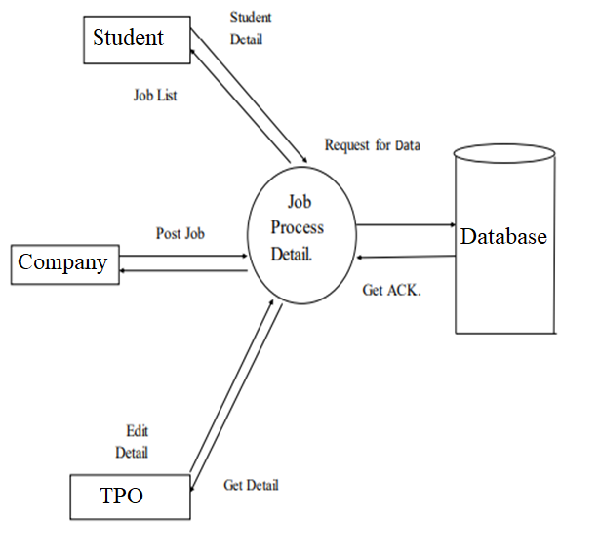

FIGURE 1:Data Flow Diagram

**LOGIN FORM PROCESS OF DFD FOR STUDENT:**

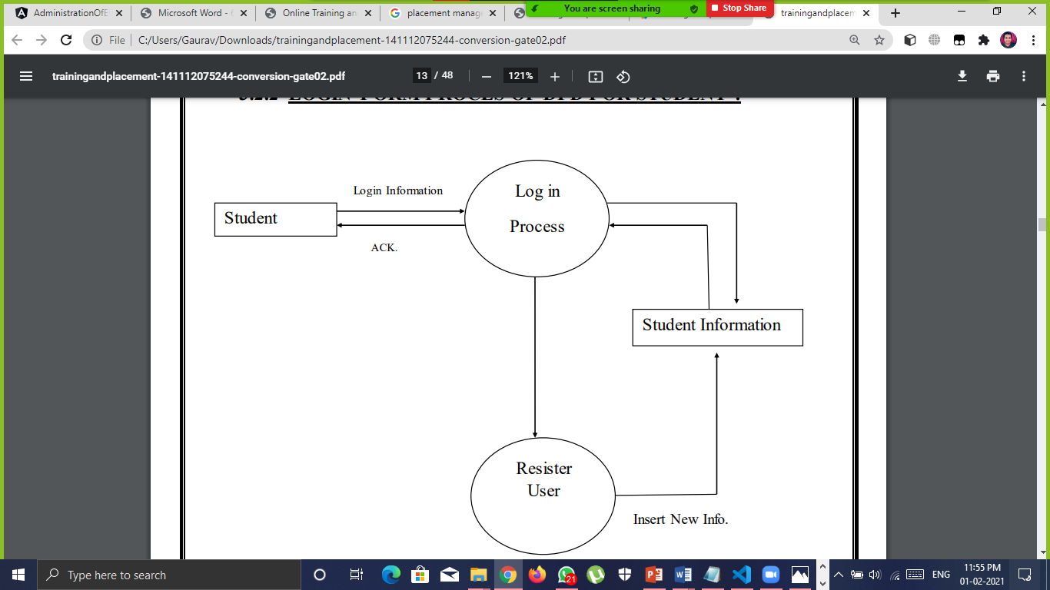

**TPO VIEW PROCESS FOR ALL STUDENTS AND COMPANIES:**

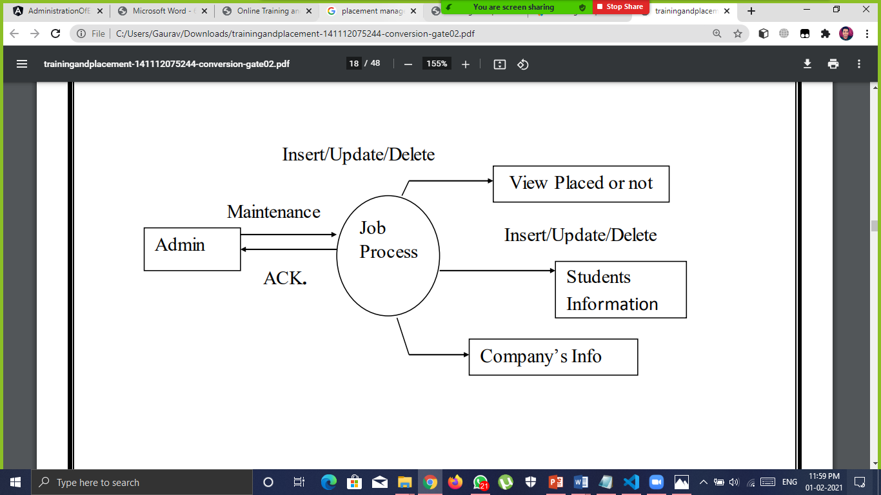

**Process Flow Diagram**

A process flow diagram is pictorial representation of algorithm, as it represents solution in from of picture. It is easier to understand and develop. A main advantage of flow chart is visibility of paths within solution, each path is clearly visible as arrows are used to represents flow.

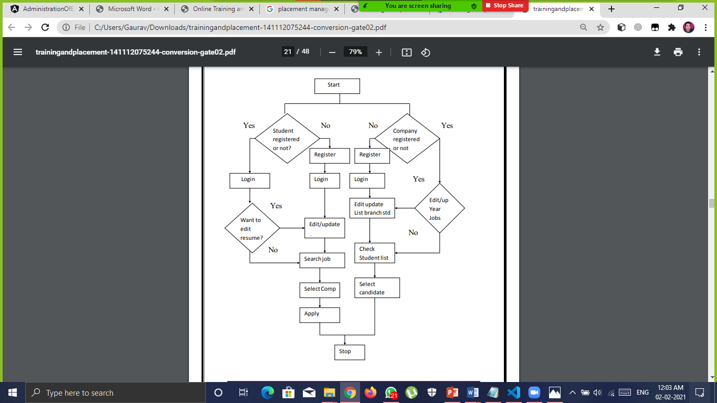

FIGURE 2:Process Flow Diagram

**Use case diagram:**

A Use case is an explanation of set of sequence of events graphically. It is rendered as an ellipse with rock-solid line up as well as lone its name. Use case diagram is a behavioural diagram that shows a set of use cases and actors and their relationship. It is a relationship among the use cases and actors. An actor represents a real-world object.

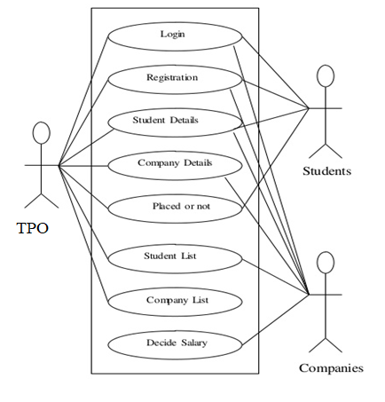

FIGURE 3:Use Case Diagram

**ER-Diagram:**

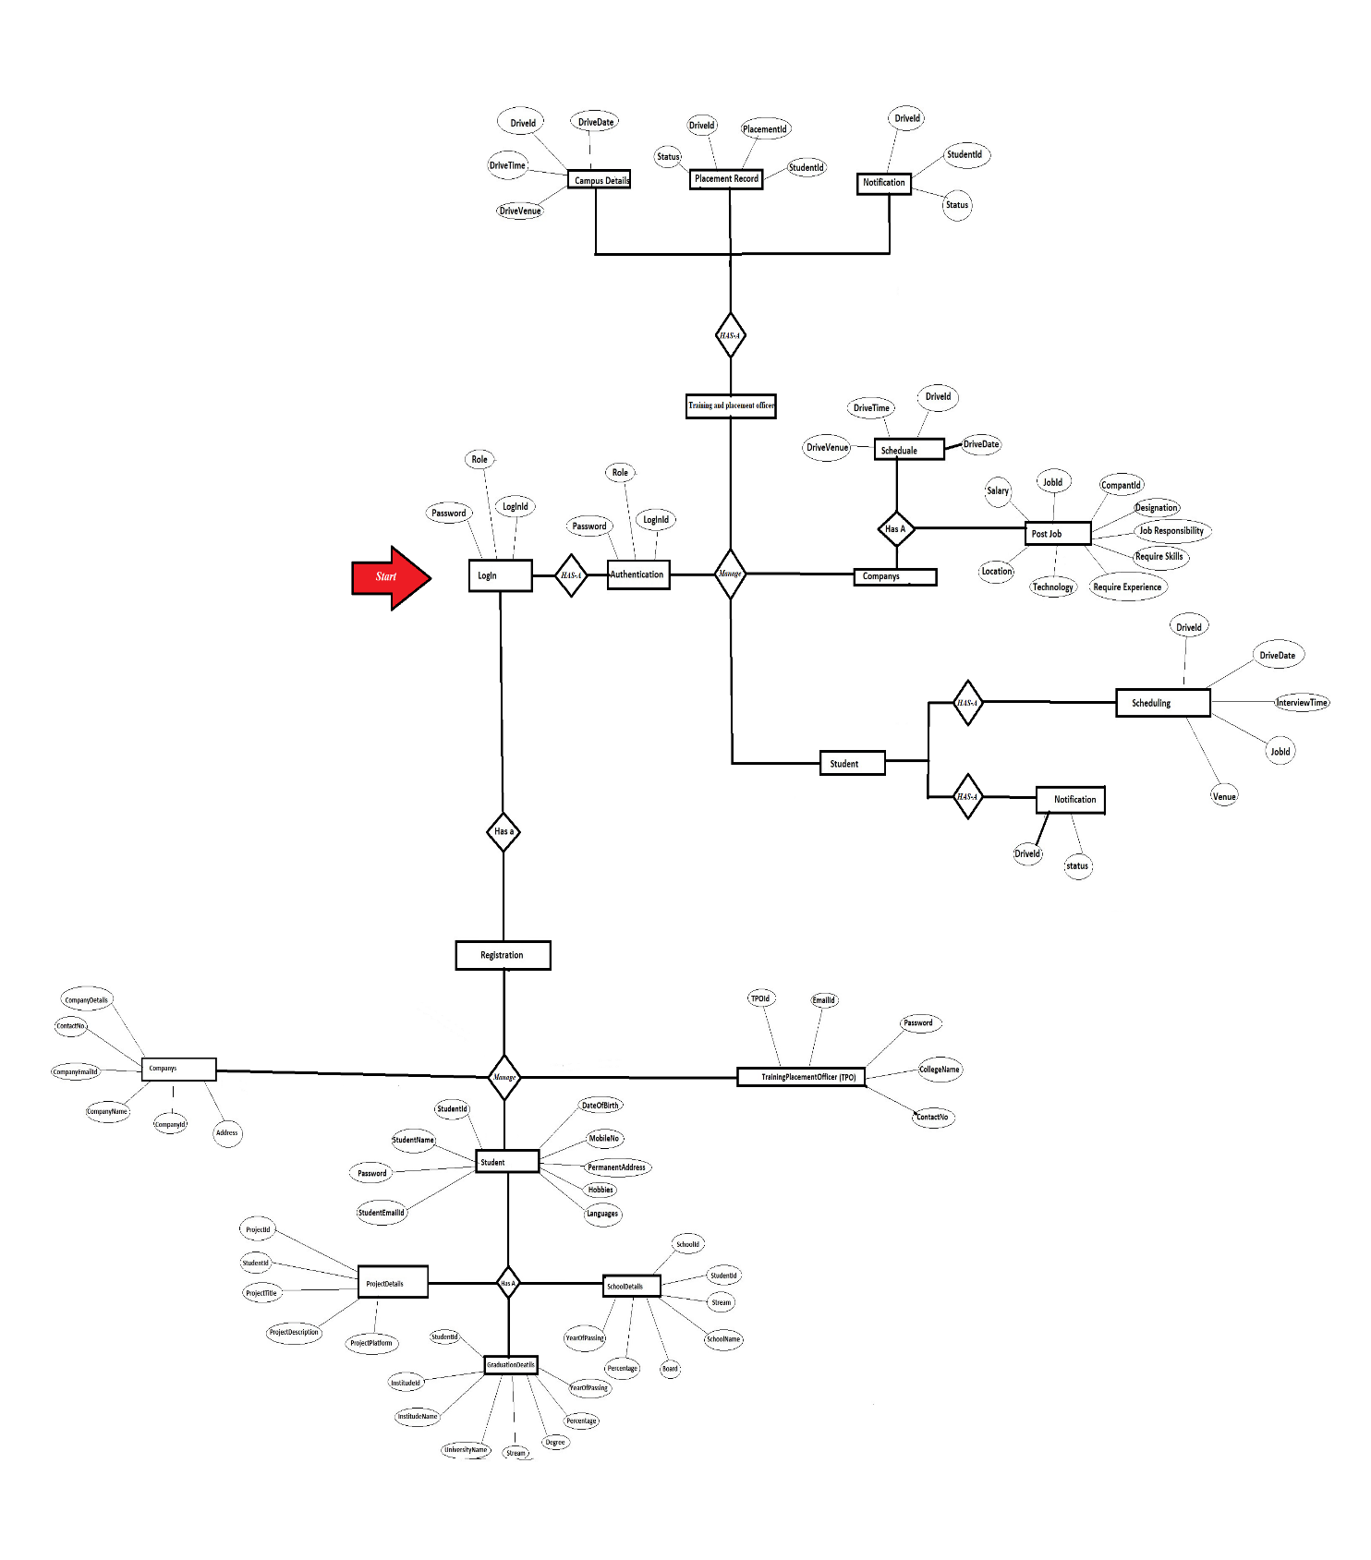

FIGURE 4:ER Diagram

**5.Table Structure**

**Company Tables**

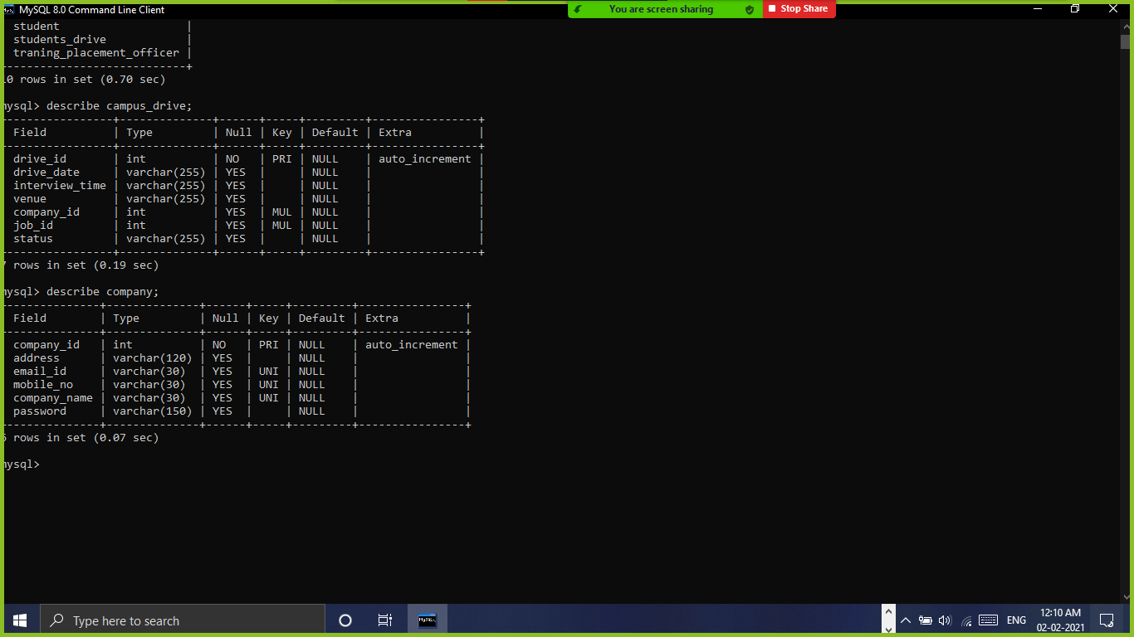

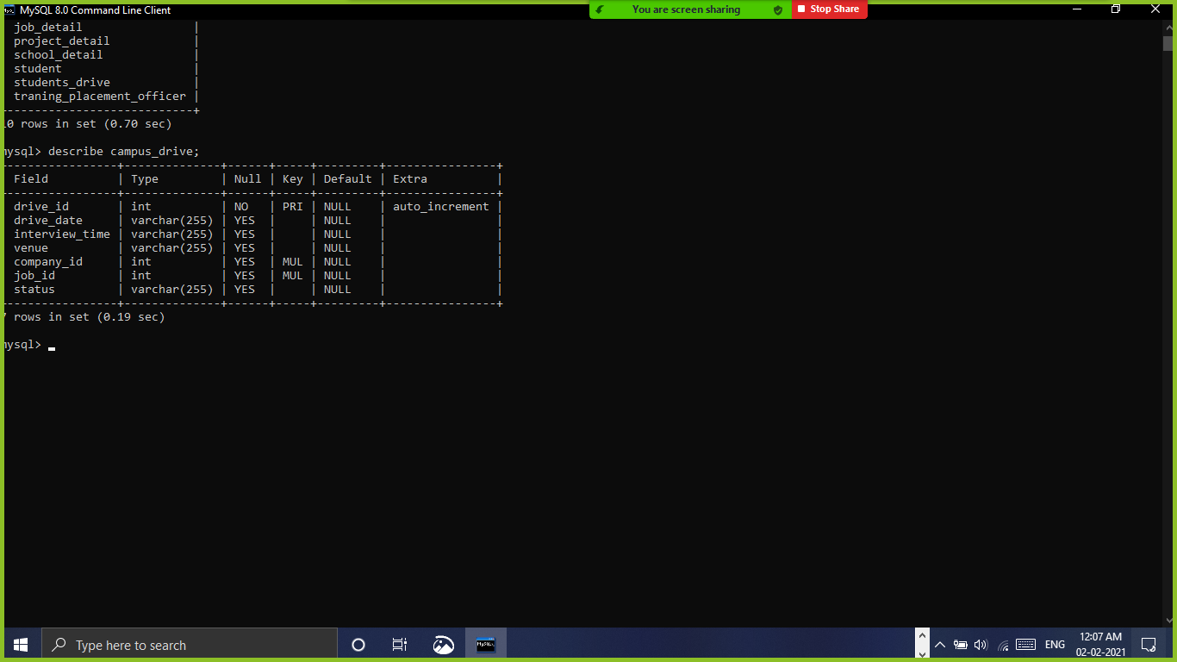

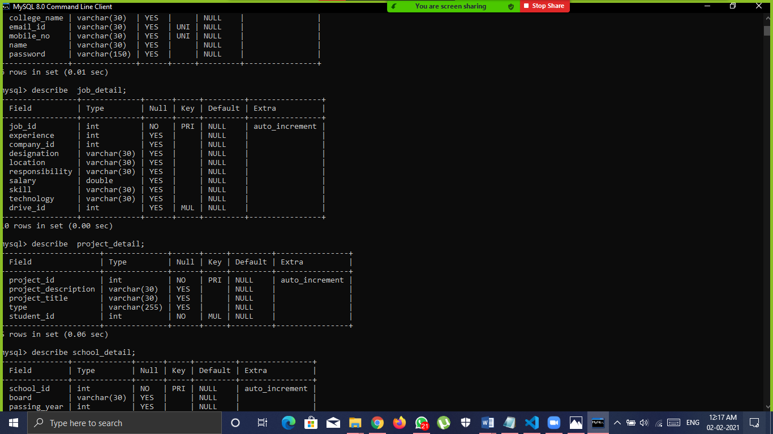

**Student Tables**

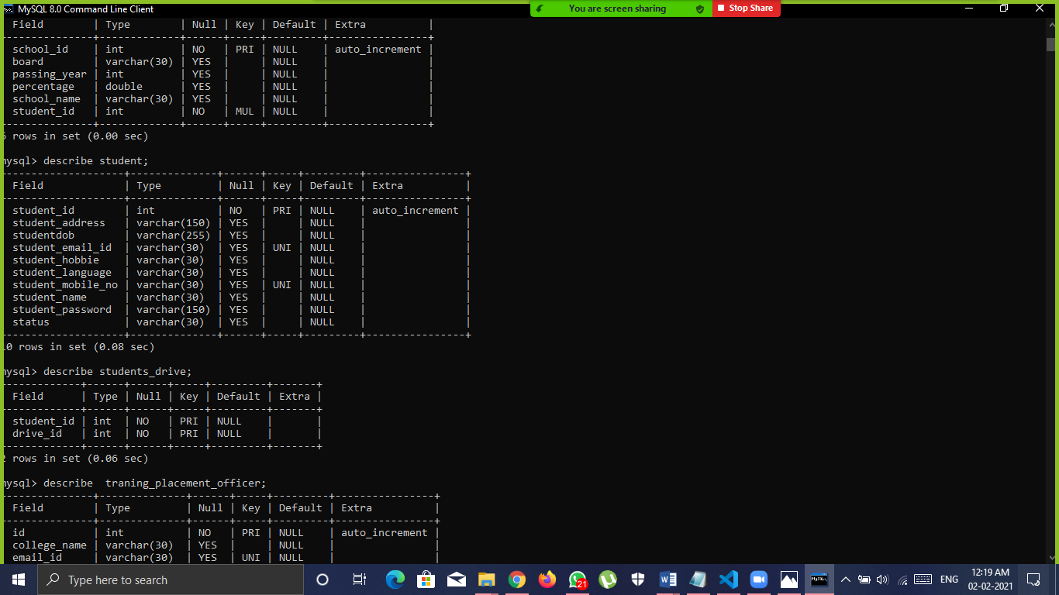

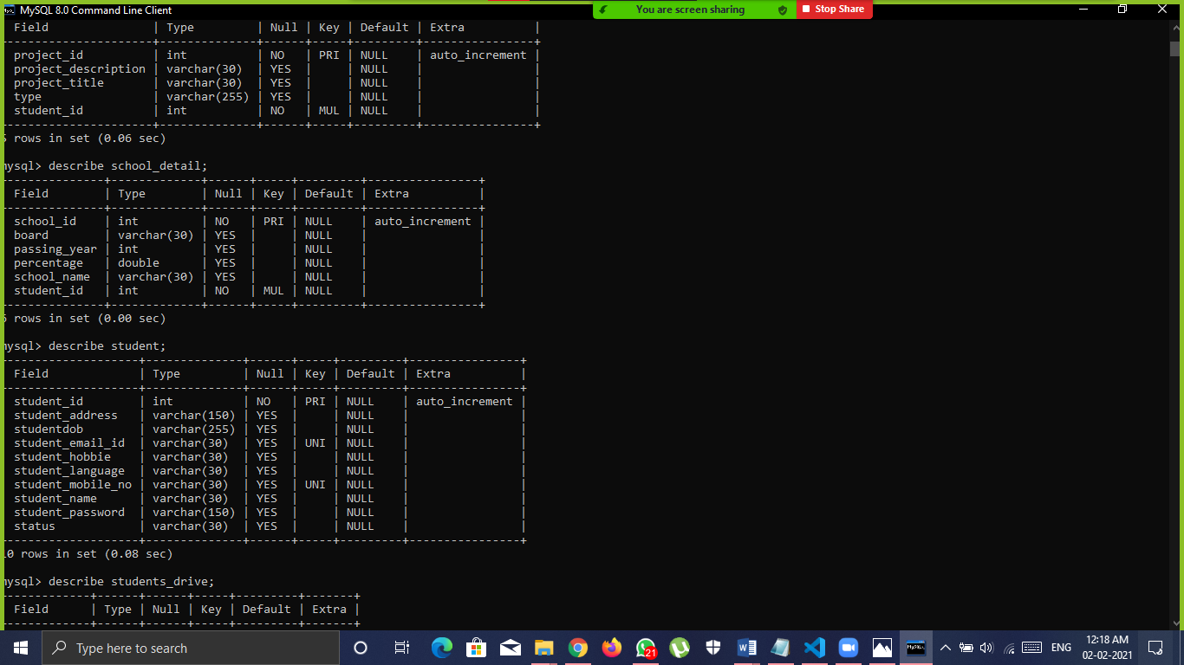

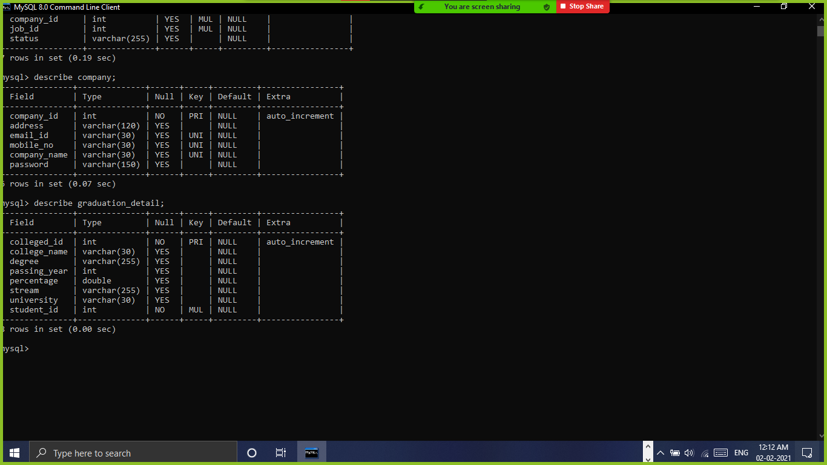

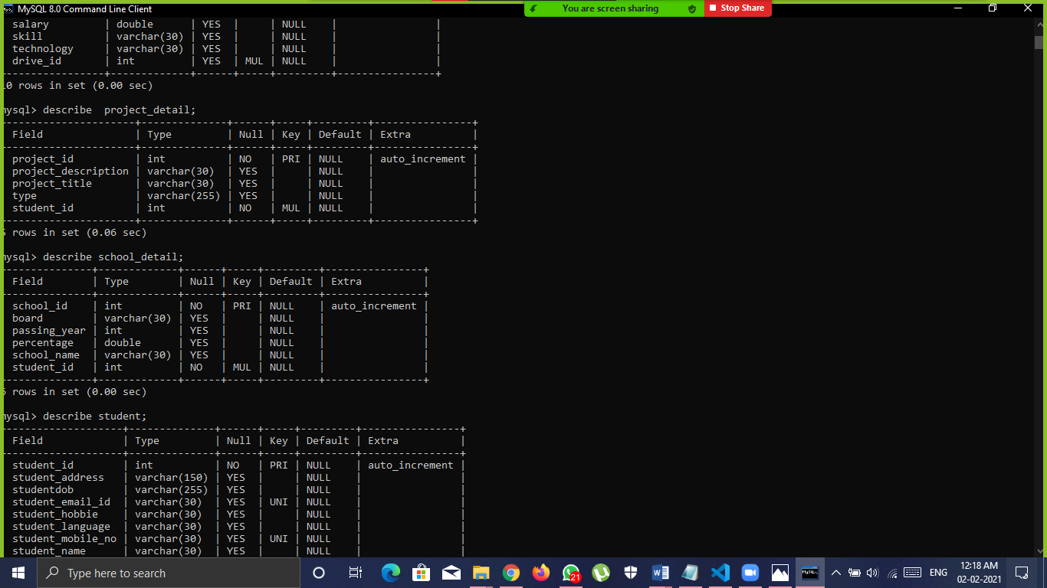

**TPO Tables**

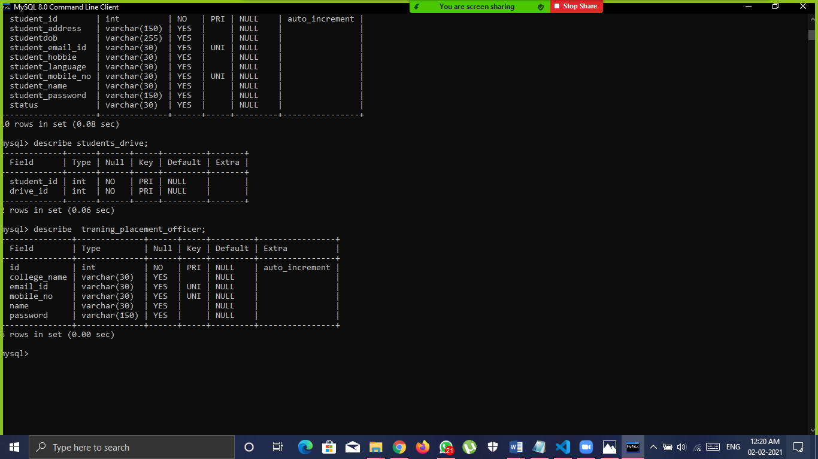



**HOD Table**

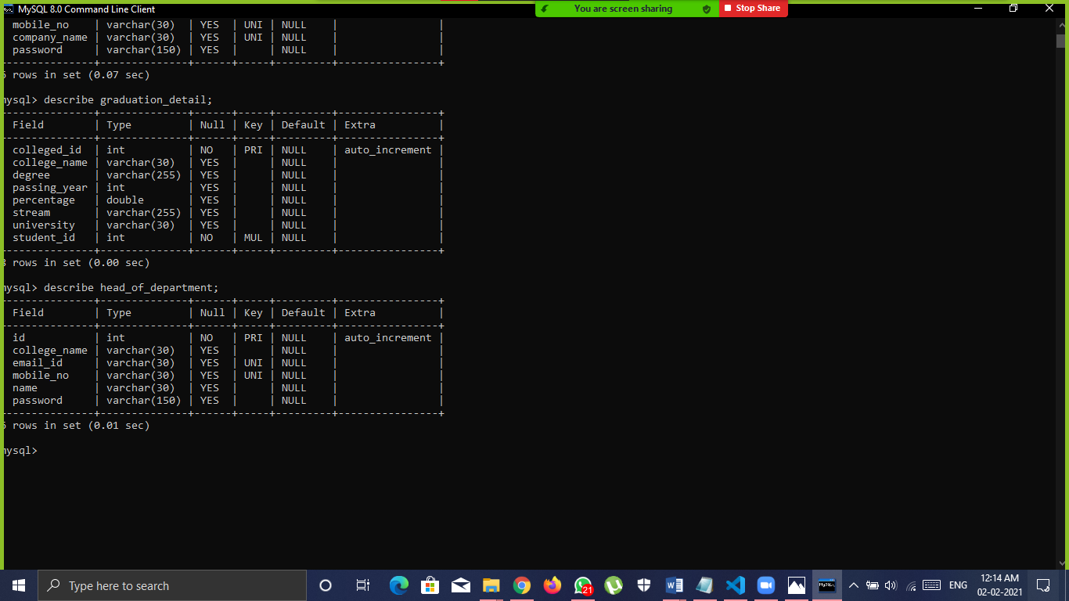

**6.Graphical User Interface**

**Home page**

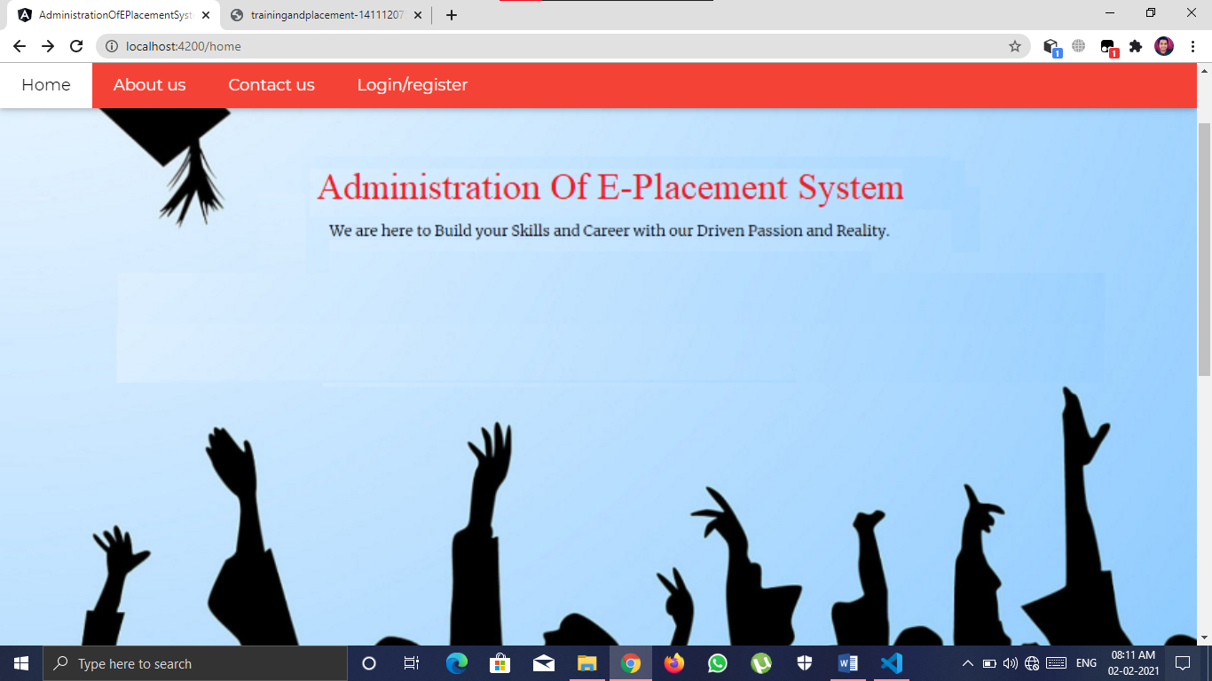

**About us page**

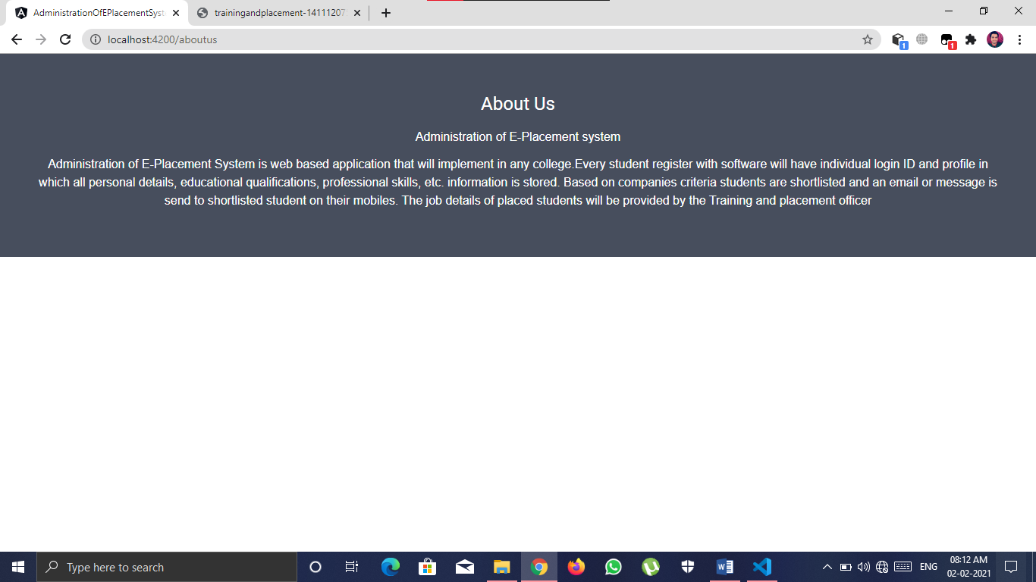

**Contact us page**

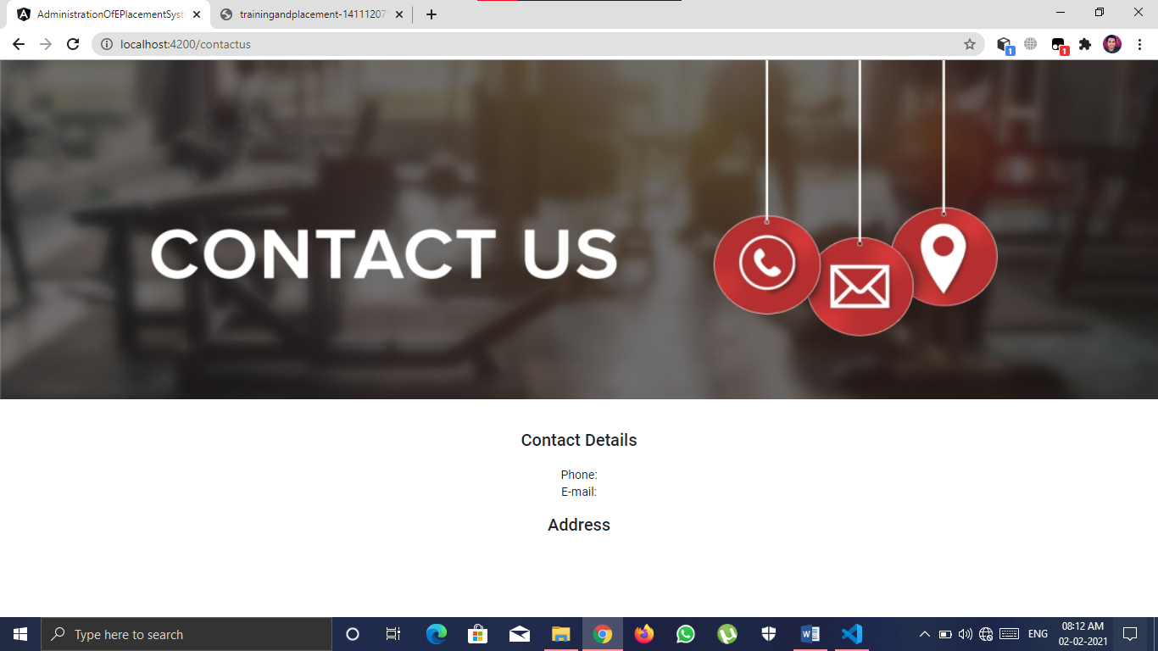

**Validation for sign in**

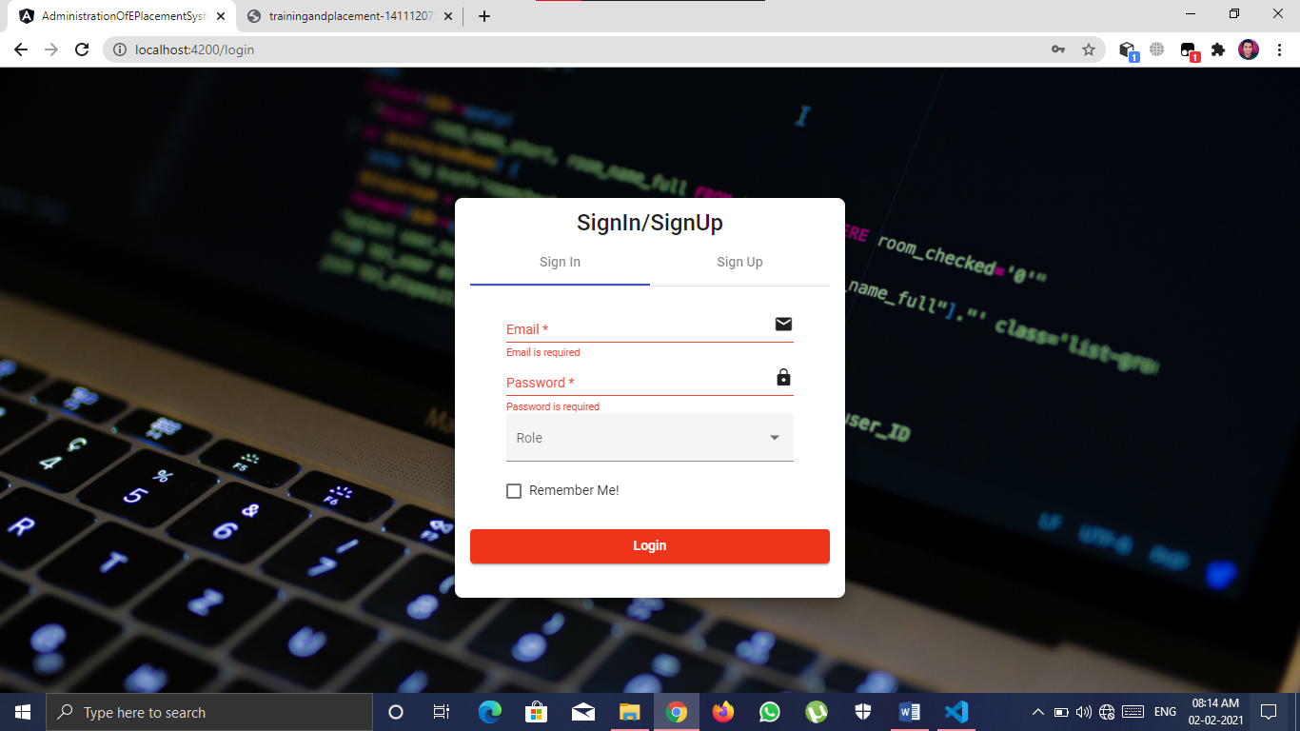

**Sign up page**

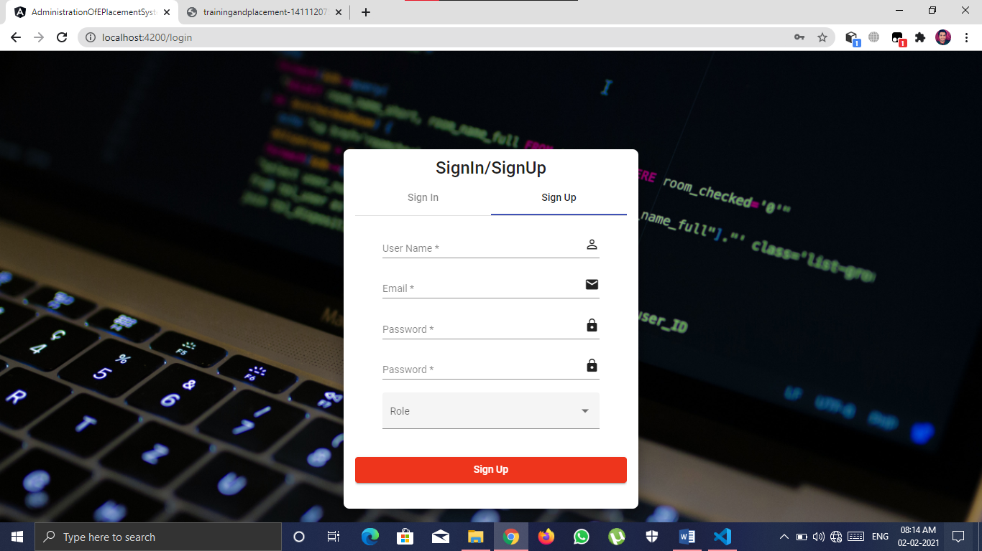

**Role based validation**

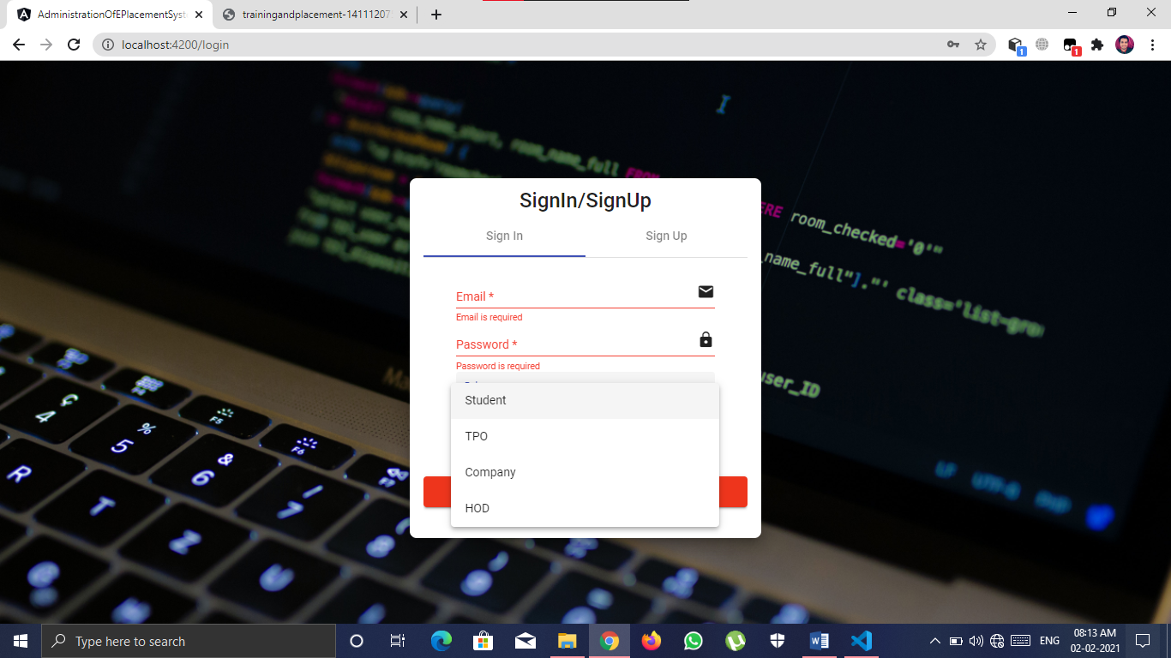

**Registration for new user**

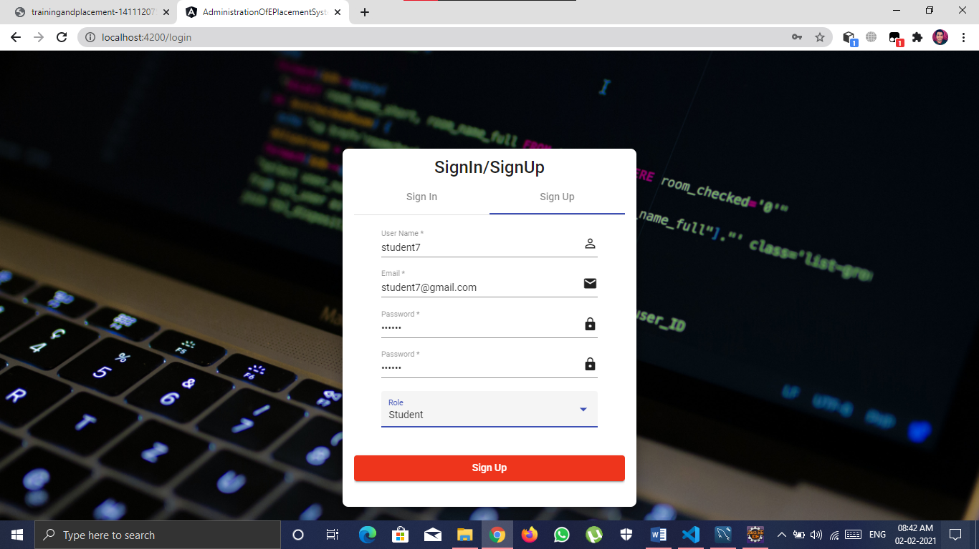

**Role based login for registered/existing user**

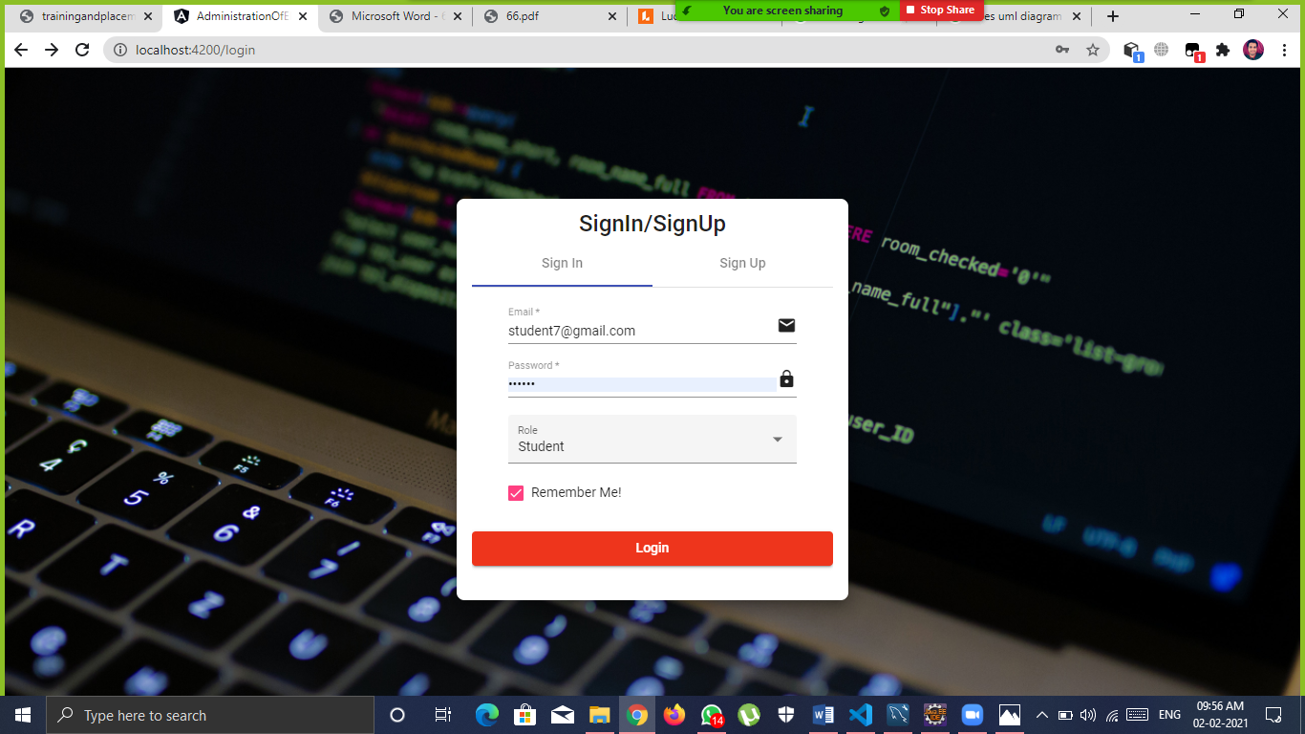

**Role based login dashboard**

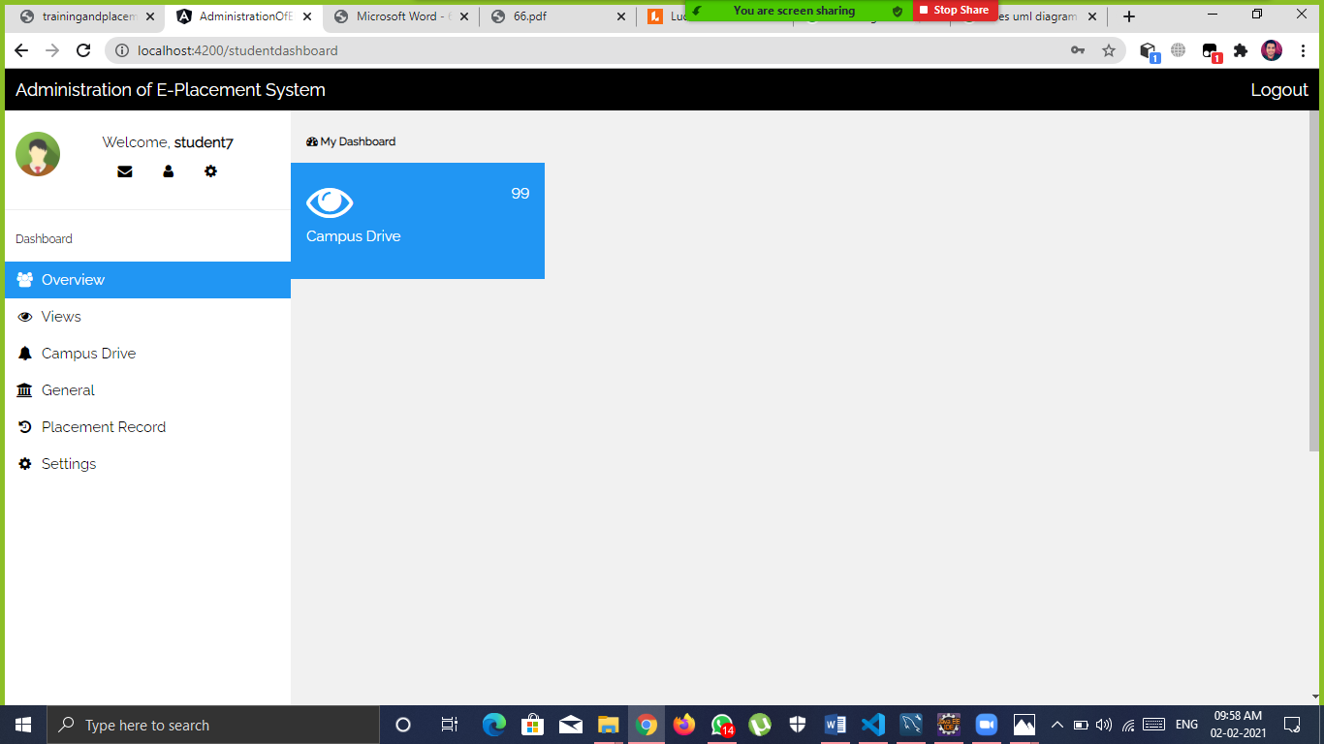

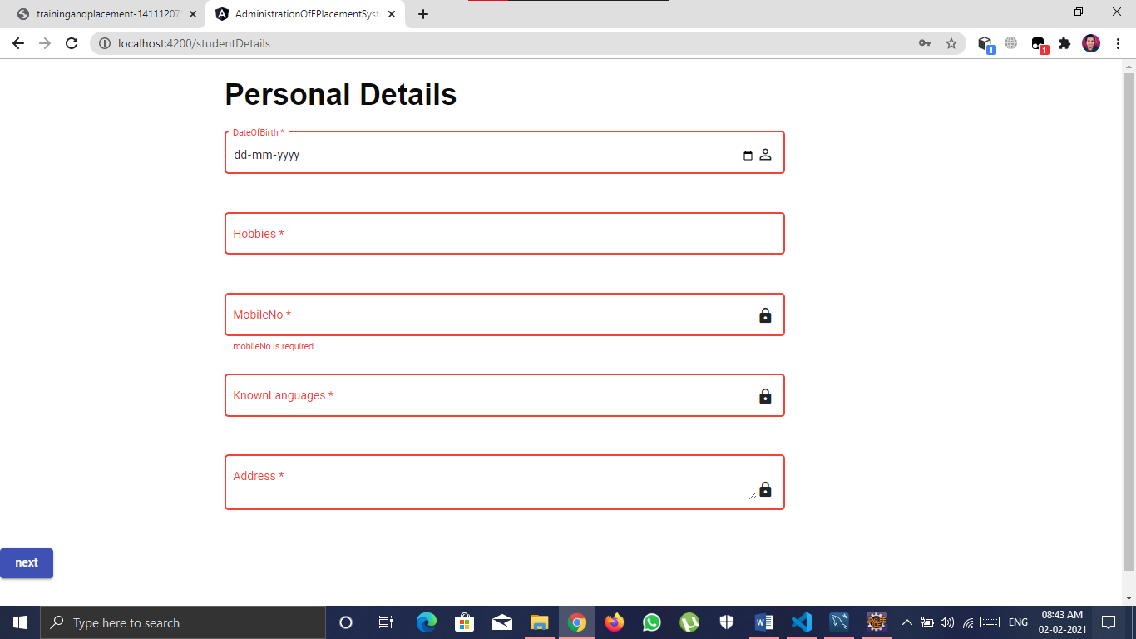

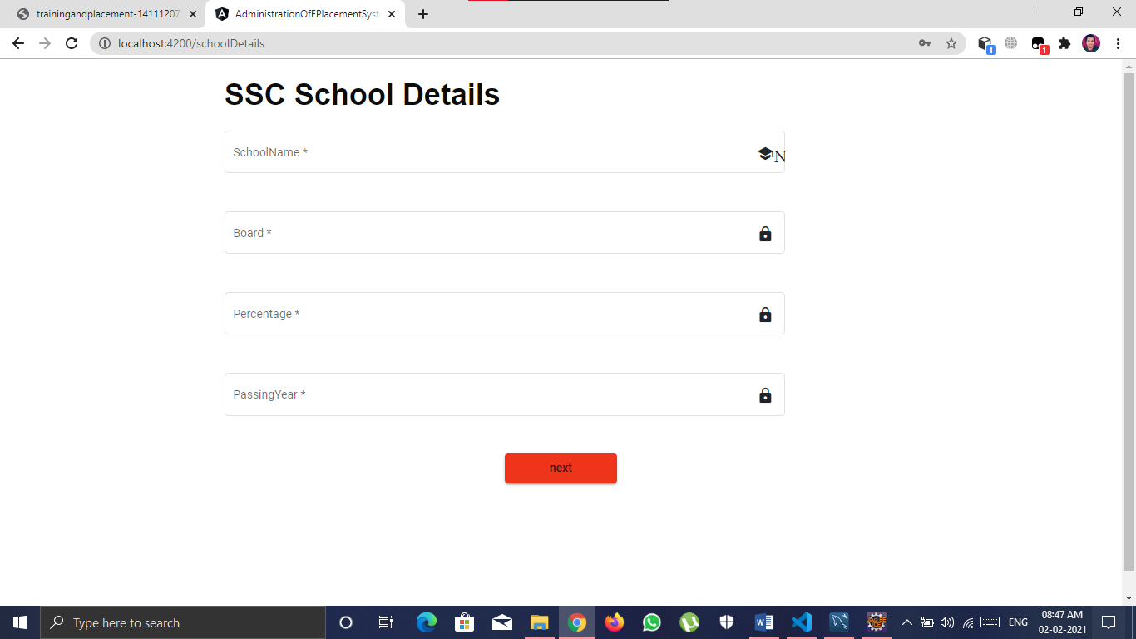

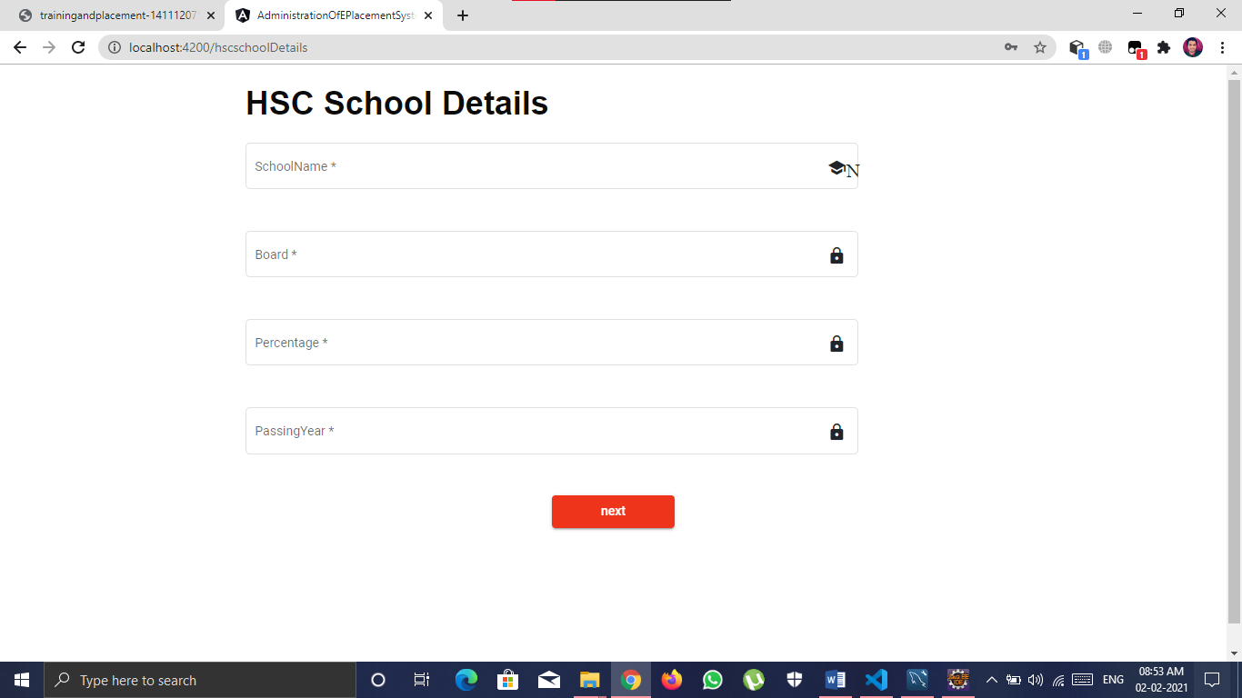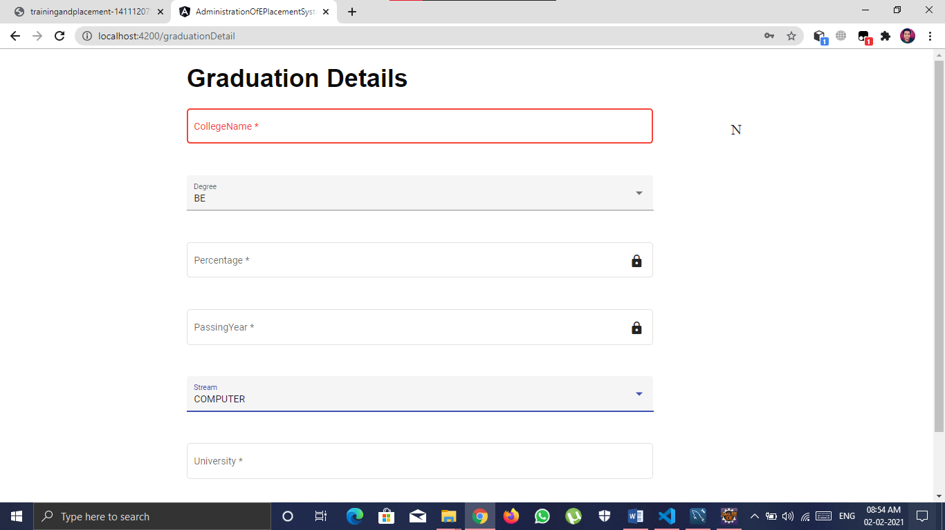

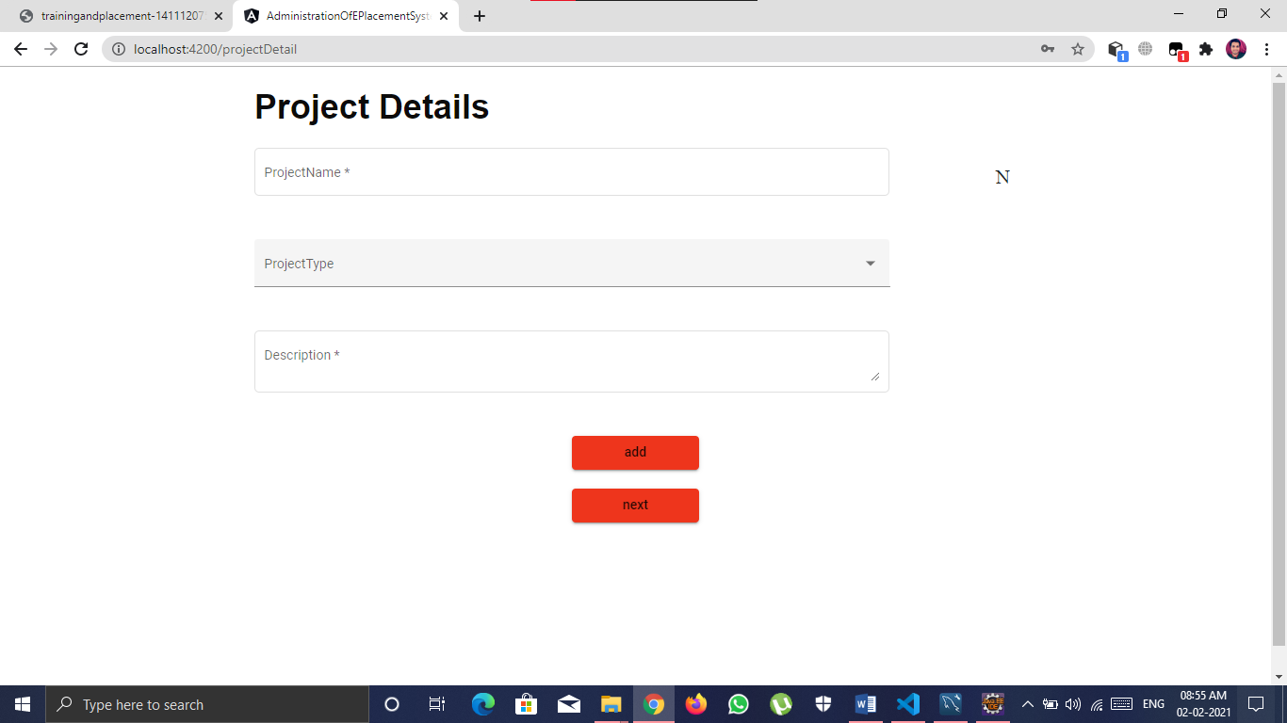

**Database view**

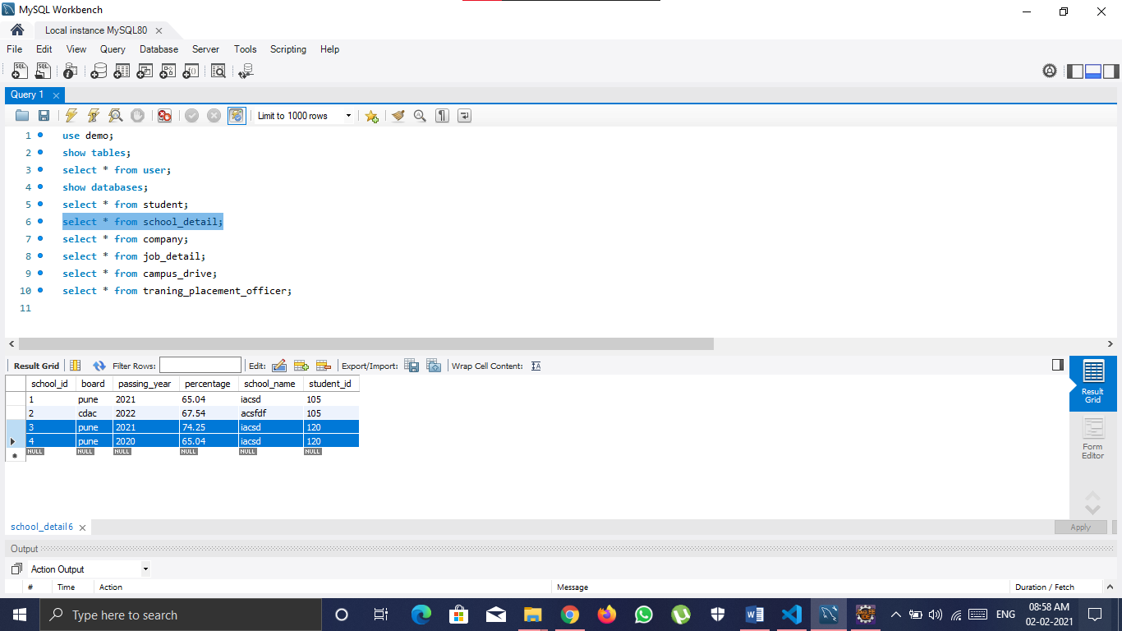

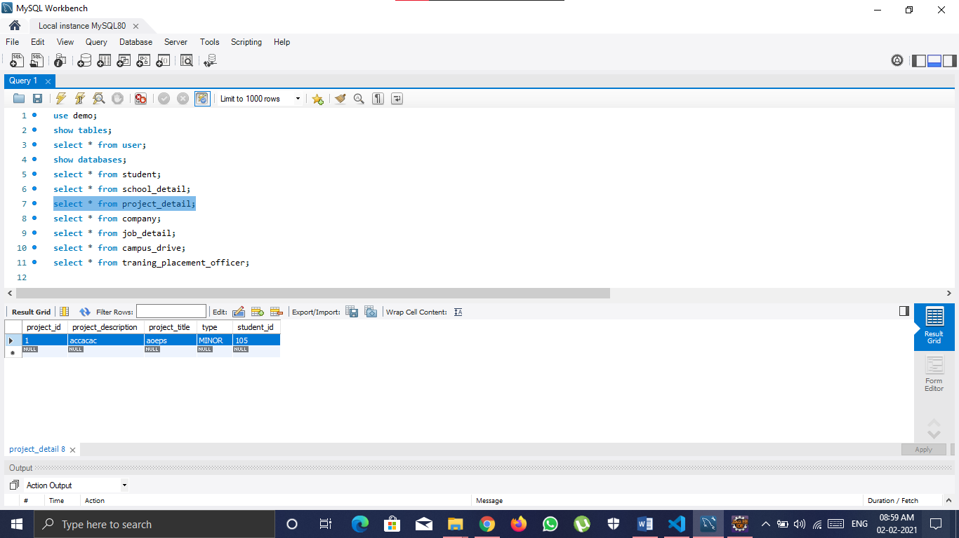

**Drive and job details**

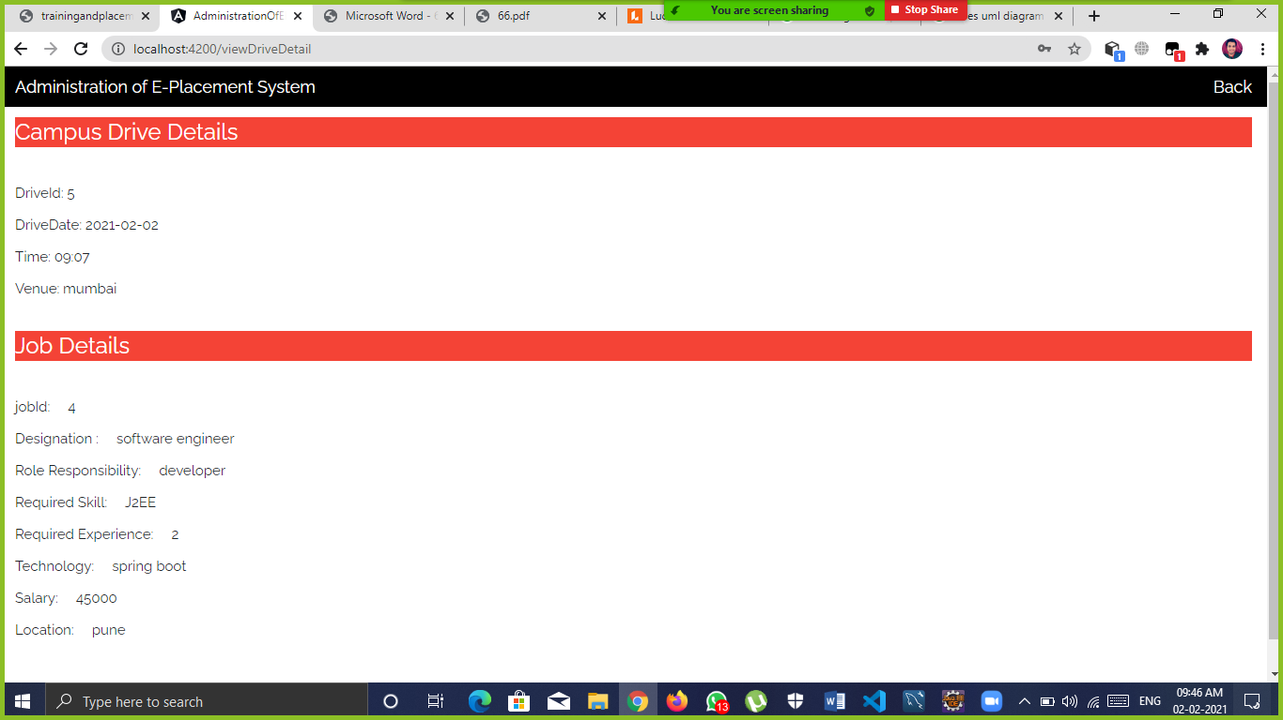

**Spring boot backend**

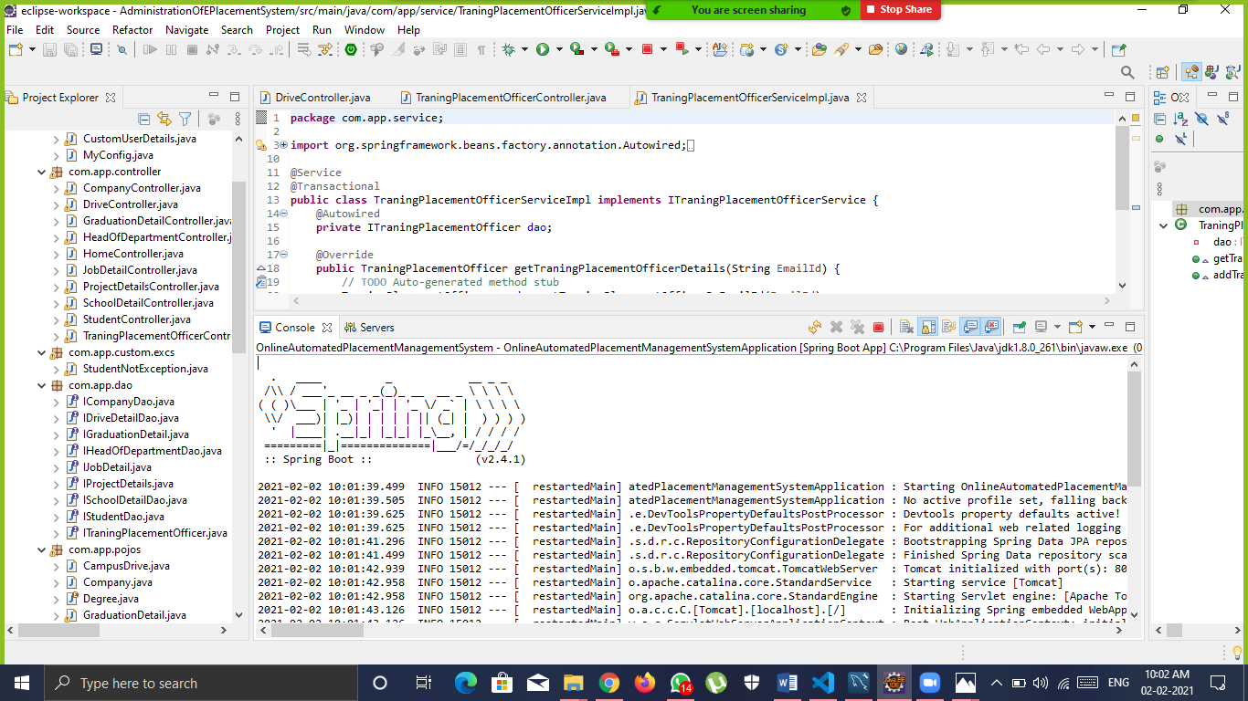

**Angular frontend**

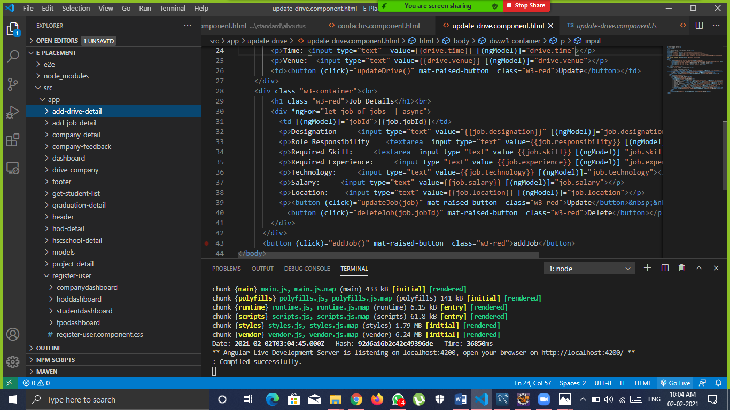

**7.ADVANTAGES AND DISADVANTAGES:**

**Advantages-**

* It is user- friendly.
* Greater Efficiency**.**

**Disadvantage-**

* Cannot work without internet connection.

**APPLICATION:**

* This system will serve as an web application for efficient planning of the placement without any hassle.
* No need to physically visit any places especially in the pandemic.

**8.FUTURE SCOPE:**

Though our project is Itself matured enough but still betterment is always an open door. In this case also we can add some features to this software to make this software more reliable.

These are as follows:

• Firstly, during the development of the project my prime object was to keep the hardware & software requirement as minimum as possible so that it supports maximum user base.

• Secondly, the searching procedure should be very strong like placement officer can search student as fast as possible.

- Thirdly, modify the project with better approach with more graphics.

- Fourthly, the back-up procedure can be incorporated to make sure of the database integrity.

• Fifthly, recruiter can visit any time through this application and communicate with Placement officer

• Sixthly, Placement officer can contact with both student and company through message. Student and company can also send message to Placement officer

**9.CONCLUSION:**

• Comparing to existing computerized system, it performs at a faster pace.

• System gives better feedback.

• Accurate information is available.

• Chances of such types of errors are much low.

• Provides security to the system & software.

• Forms are very user friendly

• User can easily work in project

• User can search for city wise company’s

• Admin can decide for who company registered or not

• User process for efficient in project

• So at last we conclude that this Project will be useful to several Students to search for better jobs and Search for Companies according to their convenience to employer.

**10.REFERENCES:**

1.Google for problem solving

2. Head First Java 2nd Edition

3. <http://www.javatpoint.com/java-Latorial>

4. http://www tutorialspoint.com/mysql/

5. https://www.w3schools.com/